Question 2:
Build a dictionary of three employees and their salary. Change the salary of one employee and show the final dictionary.
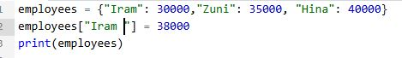
Output:

